Day 1-

Objective: Students will be able to organize their thoughts orally and in writing regarding the similarities of two distinct things -

Materials: flipchart, monsters, compare and contrast graphic organizer, sentence stems, index card or writing journal for exit slip sentence,
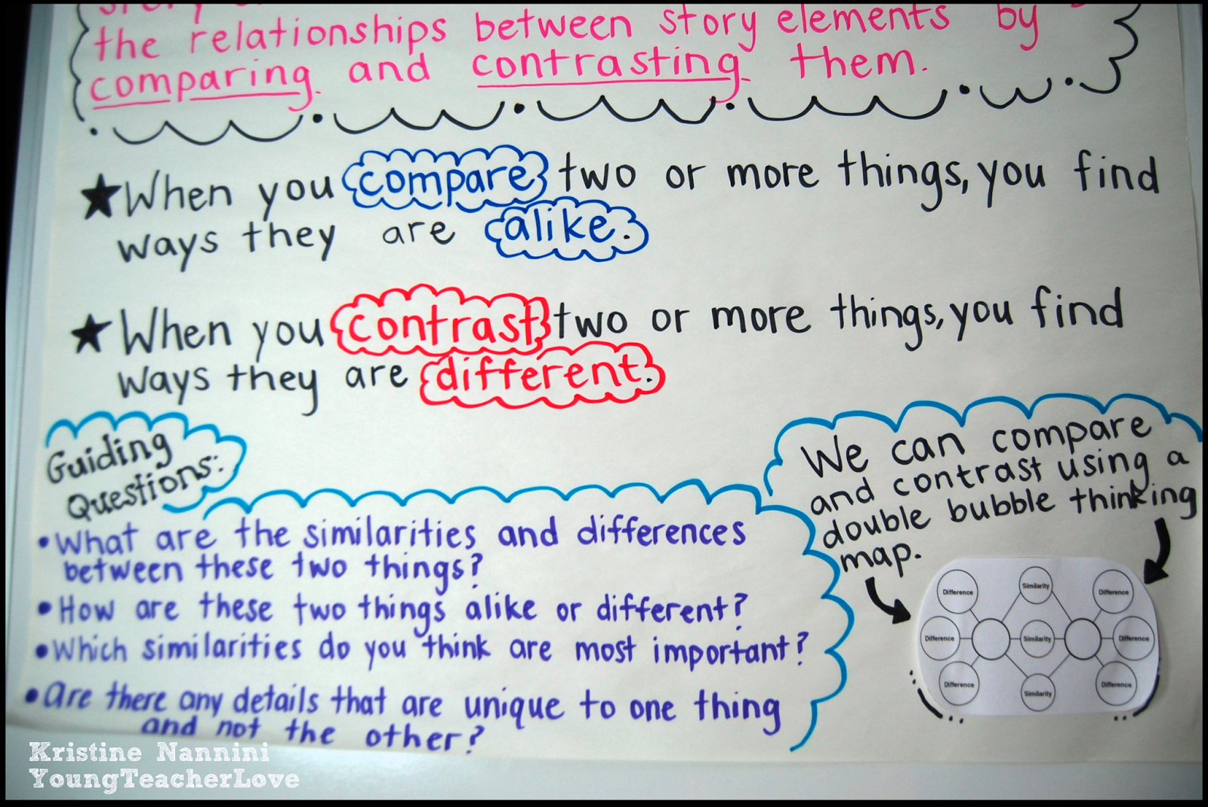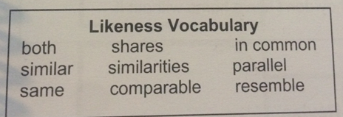
Introduction
1. Comparative thinking is one of our first and most natural forms of thought. When we are infants, one of the first differences we must identify is that between mother and other. Without the ability to make comparisons—to set one object or idea against another and take note of similarities and differences—much of what we call learning would quite literally be impossible.
Direct Inst
2. Turn and talk (1 minute) RallyRobin everything they know about spaghetti .
3. Call on students to share details. Add to flipchart.
4. Turn and talk (1 minute) RallyRobin everything they know about pizza in one word.
5. Call on students to share details. Add to flipchart.
Pizza | Spaghetti
Slice | Bowl/plate
red sauce | Marinara sauce
Cheese | Cheese on top
Bread | pasta
6. Classify the information into the t-chart/ graphic organizer.
7. Their turn: Pairs Compare Structure. Each team will get a sheet with many monsters. Choose one from the cup (person 2) and each person describes in detail the monster in their journal/whiteboard for 1 minute 30 seconds on own. Then verbalize with face partner. Mark off all word similar. Come together as a team and complete left side for monster 1.
8. Repeat with monster 2.
9. Use the details from t-chart and complete as a team the compare/contrast brainstorm planner focusing on similarities.
10. Model how to use criteria to verbally rehearse using sentence stem in flipchart. Share their monsters compare to class verbally.
Ind. Practice:
1. Students t-chart of monster for further lessons
2. Verbal sentences to show recalling of information
Assess/Closure:
Write a sentence comparing their monsters using likeness language.

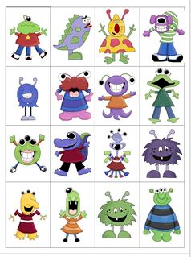Day 2- Student will be able to How do I use a graphic organizer to plan and complete a rough draft using the graphic organizer of a distinct topic.
Materials: brainstormer (GO), anchor chart, essential question, butterfly poem for teacher, butterflies and moths article, red and blue marker/crayon/pencil. Rubric, writing sample
Vocab words: compare, contrast, similarities, differences, graceful, slender, order
Introduction:
1. Explain to students that you are going to read aloud a poem about an object but you are not going to tell them the title. Inform them that after listening to the poem, each student will decide what he/she thinks the poem is about and then compare his/her decision with a partner for 1 minute.
2. Read the poem, Oh Butterfly by Fernando Perez. Allow students to compare with a partner and confirm decisions that the poem is about a butterfly. Discuss how they will be using comparisons in their next writing assessment.
3. Review any vocabulary that is/may be unfamiliar to students.
4. Before reading the Moths and Butterflies story have students predict what they think this article is going to be about.
Direct Inst.
5. Discuss compare/contrast and what it means with the students. Explain to the students that you are going to read a non-fiction story titled Moths and Butterflies and that they should read and listen carefully for points that how moths and butterflies are alike and different (review and chart guiding question prompts to help students each time they compare/contrast…What am I comparing/contrasting? What is my basis for comparison? What is my conclusion about theseobjects?).
6. Have students brainstorm how they think moths and butterflies are alike and different. Use a Likeness graphic organizer on chart paper to chart their ideas. Explain to students that we will revisit our predictions after reading our non-fiction story.
7. Read the story from Flipchart one time as the students listen attentively. Then, distribute a copy of the story Moths and Butterflies to each student to follow along and read while the teacher is reading it off of the transparency a second time. Using Think Aloud and modeling, the teacher will guide students through the passage by underlining similarities in blue and differences in red.
8. Number Head Together: Individually create their list of comparisons of moth and butterflies. Then come together as a team to share their similarities from their reading.
9. Using the graphic organizer, model writing a compare/contrast paper on the overhead or chart paper. Do this one paragraph at a time (Teachers you may choose to use the writing sample accompanying this unit…just be sure to discuss one paragraph at a time).
10. After writing/showing a paragraph as a model, the students write their own paragraphs. At first, many students may copy yours, but you model for them that they should write their own paragraphs using the same information. Their words should not be exactly like yours. Once the modeled paper is written, model revisions. Have students revise their papers. Next, edit the modeled paper. Allow students to edit their papers. Have students complete a final copy of their papers, score it using the rubric, and share with a friend.
11. How did your predictions compare to the similarities and differences you learned about moths and butterflies from our non-fiction story? What are some other nouns that you could compare and contrast?
Assessment: Mix-Pair Share How did your predictions compare to the similarities and differences you learned about moths and butterflies from our non-fiction story? What are some other nouns that you could compare and contrast?
Day 3
Objective: Student will be able to How do I use a graphic organizer to plan and complete a rough draft using the graphic organizer of a distinct topic.
Materials:graphic organizer, essential question, rubric, writing journal, red and blue marker, writing sample,

Introduction
1. Give One Get One: Brainstorm nouns that could be compared and contrasted for one minute on a sheet of notebook paper.
2. Allow the students five additional minutes to walk around the room and add additional items to their list by giving one and getting one.
3. At the conclusion of five minutes, have each student count the number of items on his/her list and award a prize or treat that student to an Edison earning.
Direct Inst
1. Discuss how many things in this world have similarities and differences. to the students that you are going to read a story entitled A Day in the Lives Of Kristy and Nick. This story is about the lives of two friends. Remind students about reading carefully in order to find similarities and differences between them (use guiding questions to assist them). 2. Students will use the information from the story to complete compare/contrast graphic organizer and write a comparison piece using their graphic organizer, a rubric, and the writing process.
2. Distribute a copy of the story, graphic organizer, and rubric to each student. Allow students once again underline similarities and differences with markers if needed.
3. Students will use their graphic organizers to write a rough draft compare/contrast piece in their own words. Remind them to use transitions, their graphic organizers, and the rubric to assist them. Students will revise and edit to make a final copy.
Independent practice:
Students will conference with the teacher and answer the essential question. Classmates will post all comparison writings in the hallway for viewing.
Assess/Closure:
Mix and Mingle: What is a compare and contrast relationship?

Day 4-

Objective:

Materials: elephant article, rubric, writing sample to critique, red and blue color, writing journal,

Introduction:
1. Five words—Three words: The teacher asks each student to brainstorm on his/her own 5 words/things that come to mind when thinking of elephants. Students then get into pairs, trios, or groups of four to share and discuss their words. Finally each small group selects 3 words from their discussions that they believe are most distinctive about an elephant. Each group will share and explain the reasons why they chose their particular words.
Preview any vocabulary that you feel will give the students difficulties.

Direct Inst
1.vExplain to the students that you are going to read a story entitled Elephants to use in writing a compare/contrast piece. Remind students about reading carefully to assist them in discovering similarities and differences between two types of elephants in the story (scaffold using guiding questions chart). Remind the students that they may need to read the story twice to ensure understanding.
2. The teacher will distribute the story, compare/contrast graphic organizer, and rubric. Students will use the information from the story to complete the graphic organizer and write a compare/contrast piece in their own words while utilizing the writing process.
Ind. Practice:
Students will score their paper using the rubric. The teacher will assess the summary using the rubric and conference with each student regarding their progress.
Assess/Closure:
How are the two objects in the story similar?
How are the two objects in the story different?

